

SDSU
ADAPTIVE
USER
GUIDE

Budget & Finance
May 2018

Table of Contents:
1 LOGIN 5
1.1 SDSU SINGLE SIGN ON (OFFICE 365) 5
1.1.1 SDSU ADAPTIVE URL 5
1.1.2 SDSU OFFICE 365 5
1.2 ADAPTIVE INSIGHTS WEBPAGE 5
1.3 CHANGE PASSWORD 6
2 HOME PAGE 7
3 PROFILE AVATAR 8
4 VERSIONS 9
4.1 ACTUAL VERSIONS 10
4.1.1 BUDGET 10
4.1.2 ACTUAL 10
4.1.3 ENCUMBRANCE 10
4.2 PLANNING VERSIONS 11
4.2.1 FY INITIAL BUDGET 11
4.2.2 INITIAL BUDGET 11
4.2.3 WORKING BUDGET 12
4.2.4 EXPENDITURE PROJECTION 12
4.3 VERSION NAVIGATION 13
5 SHEETS 14
5.1 SHEET NAVIATION 14
5.2 SHEET TOOLBAR 15
5.2.1 SHEET DISPLAY OPTIONS (FILTER) 16
5.3 SHEET RIGHT-CLICK MENU OPTIONS 17
5.3.1 SHEET COPY FORWARD 18
5.3.2 SHEET ADD SPLIT 18
5.3.3 SHEET ROW DETAILS 20
5.4 PERSONNEL – FACULTY/STAFF 21
5.4.1 DATA ENTRY – FY INITIAL BUDGET 21
5.4.2 DATA ENTRY – EXPENDITURE PROJECTION 24
5.5 PERSONNEL – STUDENT 27
5.5.1 DATA ENTRY – FY INITIAL BUDGET 27
5.5.2 DATA ENTRY – EXPENDITURE PROJECTION 29
5.6 OPERATING EXPENSE 31
5.6.1 DATA ENTRY – FY INITIAL BUDGET 31
5.6.2 DATA ENTRY – EXPENDITURE PROJECTION 33
5.7 REVENUE 35
5.7.1 DATA ENTRY – FY INITIAL BUDGET 35
5.7.2 DATA ENTRY – EXPENDITURE PROJECTION 37
5.8 BUDGET – TRANSFERS 39
5.9 ASSUMPTIONS – POSITION 40
5.9.1 DATA ENTRY – FY INITIAL BUDGET 41
5.9.2 DATA ENTRY – EXPENDITURE PROJECTION 43
6 REPORTS 46
6.1 NAVIGATION 46
6.2 REPORTS OVERVIEW PAGE 47
6.2.1 SEARCH 47
6.2.2 FOLDERS PANE 48
6.2.3 REPORTS LIST 49
6.3 RUN A REPORT 51
6.4 REPORT DRILLDOWN TO TRANSACTION 51
6.5 PRINT A REPORT 52
6.5.1 PRINTABLE VIEW 52
6.5.2 EXPORT REPORT 52
6.6 ADAPTIVE REPORT TRANSLATION 52
6.7 MATRIX REPORTS 53
6.7.1 Monthly Payroll – Actual (Pay20/40 w/ drilldown) 53
6.7.2 Monthly Payroll – Budget Plan (Pay30 w/ drilldown) 54
6.7.3 Funds Available (with drilldown) 55
6.7.4 Funds Available w/ Exp Proj (no drilldown) 56
6.7.5 Monthly Budget Plan – All Funds (incl benefits) 57
6.7.6 Monthly Budget Plan – UOF/RB Only (excl benefits) 58
6.8 MODEL REPORTS 59
6.9 TRANSACTION REPORTS 60
6.9.1 Payroll Transaction Report (Pay20/40 detailed transactions) 60
6.9.2 Transaction Report – Budget/Actual/Encumbrance 62
6.10 REPORT FILTERS 64
6.10.1 MATRIX REPORT PARAMETERS 64
6.10.2 TRANSACTION REPORT FILTERS 64
6.11 REPORT DESIGN ELEMENTS 66
6.11.1 MATRIX REPORT 66
6.11.2 TRANSACTION REPORT 69
6.12 MODIFY REPORT PROPERTIES 70
6.13 CREATE A REPORT BOOK 72
7 SUPPORT (HELP) 76
7.1 SEARCH OPTIONS 76
7.2 PRODUCT DOCUMENTATION 77
8 APPENDIX 78
8.1 BASIC TERMINOLOGY 78
8.2 KEYBOARD SHORTCUTS 79
8.2.1 WORKING WITH DATA 79
8.2.2 SHEET NAVIGATION 80
8.2.3 EXTENDING SELECTIONS IN SHEETS 81

LOGIN

SDSU SINGLE SIGN ON (OFFICE 365)

SDSU ADAPTIVE URL

Navigate to http://l.sdsu.edu/adaptive.

SDSU OFFICE 365

Navigate to Office 365 via portal.office.com.

Click on the MENU box located in the top left


Click on ALL APPS from the menu items.
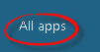

Click on ADAPTIVE SUITE from the expanded menu items.
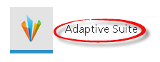

ADAPTIVE INSIGHTS WEBPAGE

Navigate to www.adaptiveinsights.com.

Click on the LOGIN icon on the top right of the menu.

Enter your USERNAME and PASSWORD and click SUBMIT.
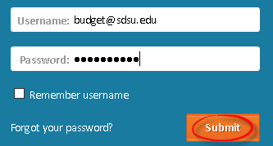

CHANGE PASSWORD

Users can change their password by clicking on the drop-down menu for the user profile icon and then clicking on SETTINGS.
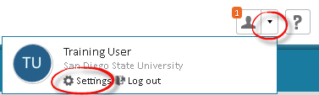

Users can then enter their OLD PASSWORD, NEW PASSWORD and
NEW PASSWORD (again) for verification. Then scroll to the bottom of the settings page and click SAVE.

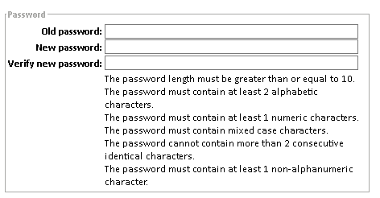



HOME PAGE

The HOME PAGE is the first page that users see after they log in.

Users can specify which HOME PAGE is displayed after log in by clicking on the drop-down menu for the user profile icon and then clicking on SETTINGS.

Users can then select one of the HOME PAGE choices from the drop-down menu. Users are encouraged to select ANNOUNCEMENTS PAGE as this is where SDSU communication will be posted.
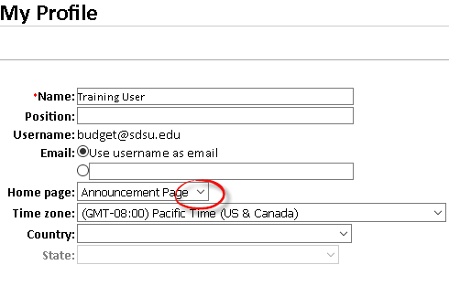

Scroll to the bottom of the settings page and click SAVE.

PROFILE AVATAR

Users may select an image to display as their avatar in their profile.
Click on the drop-down menu for the user profile icon and then clicking on SETTINGS.

Either SELECT the default avatar or browse your computer to UPLOAD AN IMAGE.

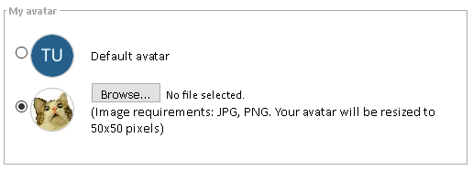

Scroll to the bottom of the settings page and click SAVE.

VERSIONS

A VERSION is a collection of data that represents a particular financial scenario.

There are two types of versions: ACTUAL versions and PLANNING versions.

Actual versions contain data from Oracle Financials refreshed as of Oracle Production the day prior. Actual versions are records of what has happened. Actual versions include (1) Budget, (2) Actual and (3) Encumbrance data as posted in Oracle Financials.

Planning versions are about financial data in the future. SDSU uses planning versions to develop budgets and to forecast expenditures. Planning versions include (1) Initial Budget, (2) Working Budget, (3) Expenditure Projection, and (4) FY Initial Budget.

The structure of your sheets, accounts, organization, dimensions, and other hierarchies stays the same between versions, but the data is different.

You select which version to view using the version selector in the upper right of many screens.

Click on the VERSION SELECTOR DROP-DOWN menu to see version options.
Use the + icon and – icon to expand or contract the version folders.
Click on a VERSION to display that version.
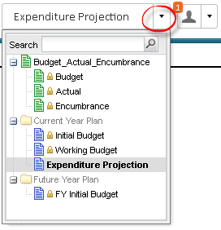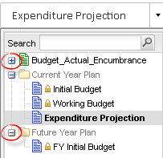

Note: The EXPENDITURE PROJECTION version is in bold as it is the default version.

ACTUAL VERSIONS

Actual versions contain data from Oracle Financials refreshed as of Oracle Production the day prior. Actual versions are records of what has happened. Actual versions are in the folder BUDGET_ACTUAL_ENCUMBRANCE and include (1) Budget, (2) Actual and (3) Encumbrance data as posted in Oracle Financials. Actual versions are LOCKED versions meaning that users can view the data but cannot edit the data.
Actual versions are accessed within REPORTS ONLY.
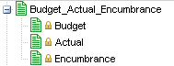

BUDGET

The actual version for BUDGET contains budget data from Oracle Financials refreshed as of Oracle Production the day prior.
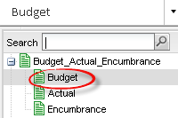

ACTUAL

The actual version for ACTUAL contains actual data from Oracle Financials refreshed as of Oracle Production the day prior.
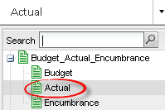

ENCUMBRANCE

The actual version for ENCUMBRANCE contains encumbrance data from Oracle Financials refreshed as of Oracle Production the day prior. 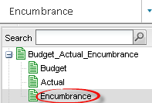

PLANNING VERSIONS

Planning versions are about financial data in the future and contain data input by Adaptive users and/or Budget & Finance. SDSU uses planning versions to develop budgets and to forecast expenditures. Planning versions include (1) FY Initial Budget, (2) Initial Budget, (3) Working Budget, and (4) Expenditure Projection.
Planning versions reside in two folders: FUTURE YEAR PLAN and CURRENT YEAR PLAN. The FUTURE YEAR PLAN folder includes (1) FY INITIAL BUDGET. The CURRENT YEAR PLAN folder includes (1) INITIAL BUDGET, (2) WORKING BUDGET, and (3) EXPENDITURE PROJECTION.
Planning versions may be LOCKED versions meaning that users can view the data but cannot edit the data. The (1) Initial Budget and (2) Working Budget versions will always be locked versions.

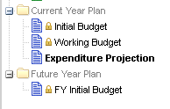

FY INITIAL BUDGET

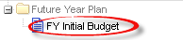

The FUTURE YEAR PLAN folder includes the FY INITIAL BUDGET version. This planning version is where the initial (July) budget is developed. This version will be UNLOCKED for data entry during the period when the initial budget is in development. Once the FY INITIAL BUDGET version is finalized, it will be LOCKED. When the new FY opens in July, the FY INITIAL BUDGET version budget data will be uploaded to Oracle and the FY INITIAL BUDGET version will replace the INITIAL BUDGET version in the CURRENT YEAR PLAN folder.

INITIAL BUDGET

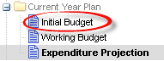

The CURRENT YEAR PLAN folder includes the INITIAL BUDGET version. This planning version is the initial (July) budget. The initial (July) budget is developed in the FY INITIAL BUDGET version and is then copied to the INITIAL BUDGET version in July. The INITIAL BUDGET version is always LOCKED.

WORKING BUDGET

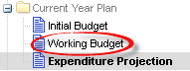

The CURRENT YEAR PLAN folder includes the WORKING BUDGET version. This planning version is the INITIAL BUDGET version adjusted to include processed BUDGET TRANSFERS to provide the working budget (or current budget) for the fiscal year. The WORKING BUDGET version is always LOCKED.

EXPENDITURE PROJECTION

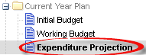

The CURRENT YEAR PLAN folder include the EXPENDITURE PROJECTION version. This planning version is where users can enter data for planned expenditures or commitment of funds for open accounting periods. This version allows users to capture financial data that is not reflected in Oracle as an ACTUAL or ENCUMBRANCE so it can be displayed in reports to reflect a more accurate funds available. The EXPENDITURE PROJECTION version is always UNLOCKED.

VERSION NAVIGATION

To display and/or enter data in Adaptive, it is important to ensure you have selected the appropriate version. The version selection menu is located on the top right of the screen to the left of the user profile.

Click on the VERSION SELECTOR DROP-DOWN menu to see version options.
Use the + icon and – icon to expand or contract the version folders.
Click on a VERSION to display that version.

SHEETS

A SHEET is where users view, enter, and update financial data. SDSU has developed multiple sheets to capture the various types of personnel and financial data used in budget and reporting processes. Sheets are used for budget development and expenditure planning.

SHEET NAVIATION

Click SHEETS from the navigation menu to see your sheets listed in the submenu. Click any SHEET to view it.
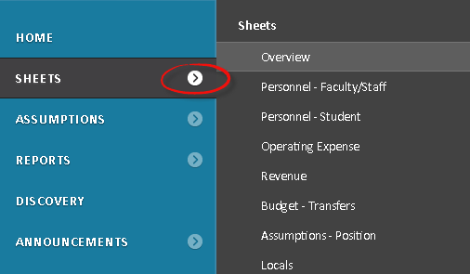

Or, click OVERVIEW to go to the sheets overview page.
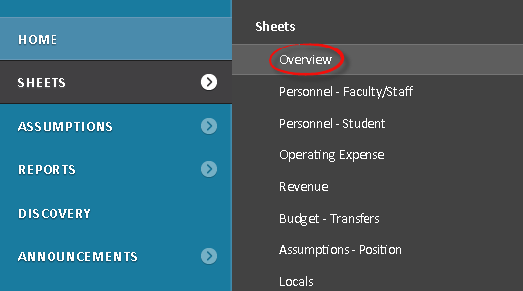

Click any SHEET to view it.
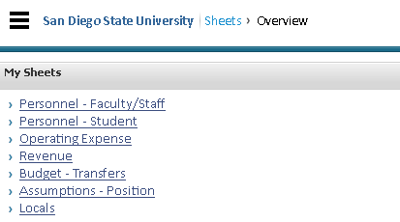

SHEET TOOLBAR

The following functions are available from the sheets toolbar:
- Expand/Collapse Formula Bar – shows/hides formula bar
- Formula Assistant – opens the formula assistant
- Save – commits all changes to the database
- Add Row – adds a new row onto the sheet. If more than one cell is currently selected, or new rows cannot be added, this button is inactive.
- Delete Row – deletes the row with the currently-selected cell from the sheet. If more than one cell is currently selected, this button is inactive
- Copy Formula/Value Mode – toggles between Copying the Value of Selected Cells or Copying the Formulas (shown). Works in combination with Ctrl-C when copying data within a cell
- Display Options (Filter) – allows users to select from the viewable time range, column display options (i.e. months, quarters, years) and suppress rows if zeros or blanks options
- Cell Explorer – allows users to drill into the contents of a cell and how its value is calculated
- Printable View – generates a printable view of the data on the sheet by exporting to Microsoft Excel
- Clear All Edits – erases all unsaved changes on the sheet
- Refresh Sheet – discards all unsaved changes on the sheet and reloads the sheet from the database. If other users have saved changes, the refresh will reflect those updates

SHEET DISPLAY OPTIONS (FILTER)

Click DISPLAY OPTIONS from the sheet toolbar.

Select the COLUMN DISPLAY OPTIONS you would like to display on the sheet.
Click on APPLY.
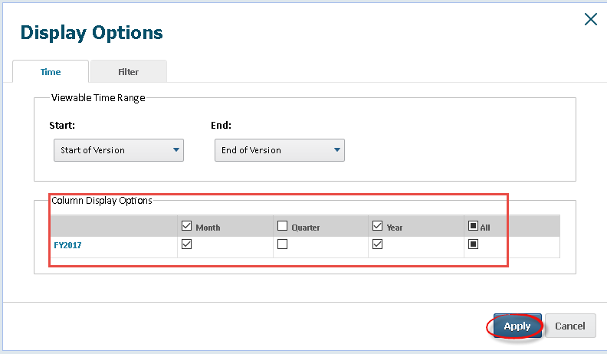

Select the FILTERS tab and select a COLUMN along with the criteria.
Click on APPLY.
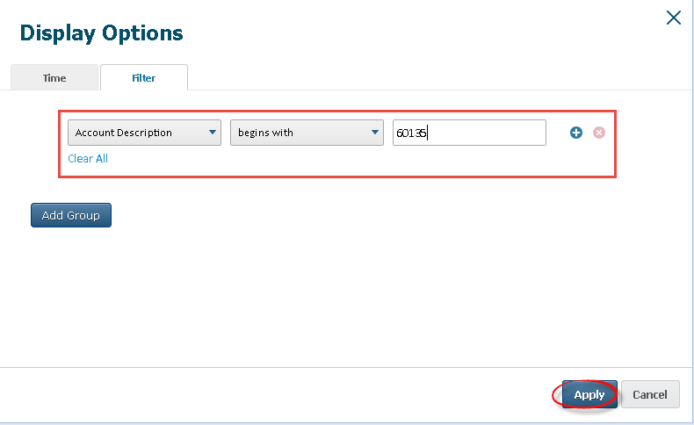

SHEET RIGHT-CLICK MENU OPTIONS

Several of the toolbar options can also be accessed from the right-click menu.
- Clear: Erase the current contents of the cells by setting their values to zero.
- Copy Forward: Not available for rollups. A submenu with two choices:
  - Copy Forward To End: Copies the value or formula of the currently-selected cell into every cell on the current row of the version, from the currently-selected cell to the end of the row.
  - Advanced: Allows you to specify how far to copy the value forward, and how to change the value in each cell, if desired (e.g. increase it by 10% each month).
- Formula Assistant: Begin editing the contents of the cell using the Formula Assistant.
- Adjust: Used to adjust the values of all cells in the selected range. Adjustments can raise or lower the values in the cells by a percentage or by a fixed amount. If you adjust cells that contain formulas, those formulas are replaced with numeric values.
- Add Note: Add a note to the cell.
- Edit Note: Edit a note attached to the cell.
- Remove Note: Remove the note attached to the cell.
- Add Split: Adds a new split to the account whose cell is selected. You cannot add splits in a cumulative plan-by-delta account.
- Rename Split: Renames the current split of the account.
- Delete Split: Deletes the current split of the account.
- Add Row: Modeled sheets only. Adds one or more new rows to the sheet. Choose the number of rows to add from the context menu.
- Copy Row: Copies the selected row or rows to the end of the sheet.
- Delete Row: Deletes the selected row or rows from the sheet.
- Row Details: Displays the values for all Modeled Accounts associated with the current sheet for the selected row.
- Explore Cell: Opens the Cell Explorer on the selected cell. This button is active only if the cell contains value for formula.

SHEET COPY FORWARD

Enter an amount in the timespan and RIGHT-CLICK on the cell.
Click COPY TO END.
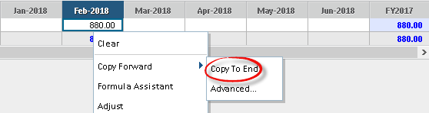

Amount is copied into each future period up to the last period.
Note: Data entered and not saved will be blue font.
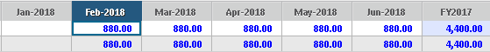

Click on the SAVE icon from the toolbar to save.

Note: Data entered changes from blue to black font upon save.
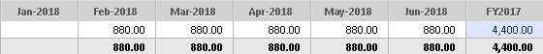

SHEET ADD SPLIT

Only the OPERATING EXPENSE and REVENUE sheets allow split rows.

RIGHT-CLICK on a row and click on SPLIT ROW.
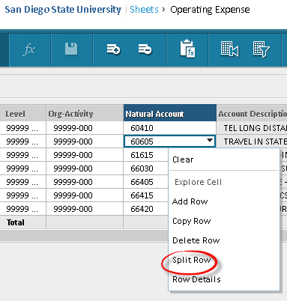

You can add multiple splits. Enter AMOUNT in the timespan for each split.
Note: Data entered and not saved will be blue font.

Click on the SAVE icon from the toolbar to save.

Note: Data entered changes from blue to black font upon save.

SHEET ROW DETAILS

RIGHT-CLICK on a row and click on ROW DETAILS.
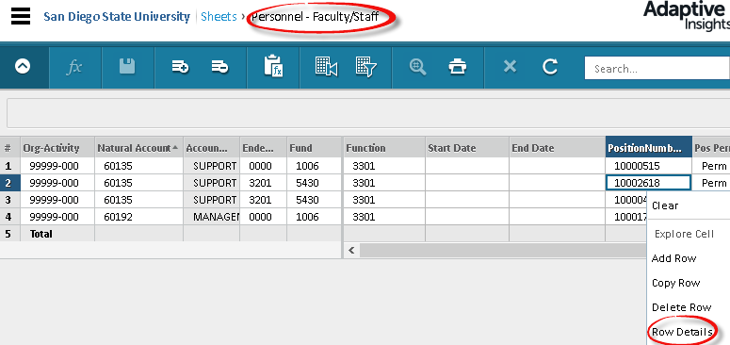

A new window (pop-up) will open and display the row details.
The row details items is most applicable to personnel data as it provides the benefits and risk pool amounts and rates that are not included in the row display. Use the SCROLL BAR to display data to the left and right.
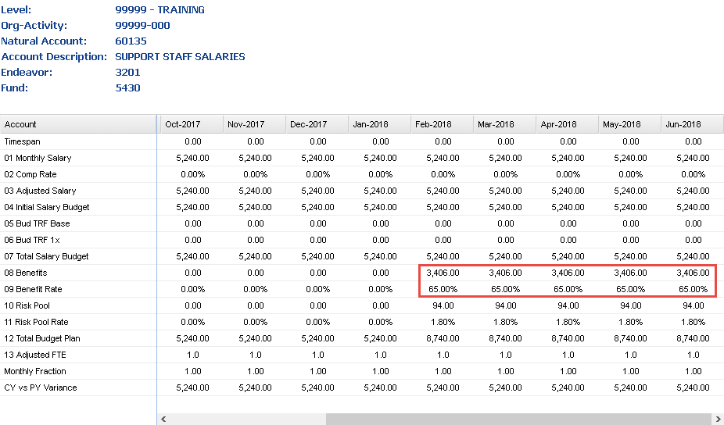

PERSONNEL – FACULTY/STAFF

The PERSONNEL – FACULTY/STAFF sheet is where users view, enter, and update information for faculty/staff (including management) accounts.

Click SHEETS from the navigation menu to see your sheets listed in the submenu. Click PERSONNEL – FACULTY/STAFF to view sheet.
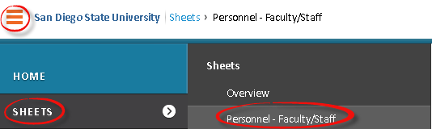

DATA ENTRY – FY INITIAL BUDGET

Click on FY INITIAL BUDGET to display version.
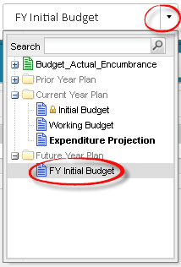

Select the LEVEL to display from the level drop-down menu.


Budget & Finance will pre-populate the PERSONNEL – FACULTY/STAFF sheet for the FY INITIAL BUDGET version based upon direction from each divisional coordinator.

The columns in the PERSONNEL – FACULTY/STAFF sheet allow users flexibility to plan their initial budget based on divisional/college/department business process.
- Level – required (will only display if you select a parent level)
- Org-Activity – required (format ORGXX-ACT)
- Org-Activity Description – view only (attribute of ORG-ACTIVITY)
- Natural Account – required
- Account Description – view only (attribute of NATURAL ACCOUNT)
- Endeavor – required
- Fund – required
- Function – required
- Start Date – optional (required for Lump Sum)
- End Date – optional
- Position Number – optional, select from drop-down list
- Pos Perm/Temp – optional, select from drop-down list
- Pos HeadCount – optional
- JobCode – optional, select from drop-down list
- Job Code Title – view only (attribute of JOB CODE)
- Working Title – optional
- Union Code – optional (required for compensation increases)
- Union Code – view only (attribute of JOB CODE)
- Empl ID – optional, select from drop-down list (updated monthly after payroll posts)
- Empl Name – view only (attribute of EMPL ID)
- Empl Status – optional
- Comp Rate – amount that applies to Frequency (i.e. monthly salary)
- Frequency – select from drop-down list
  - Annual: amount for fiscal year (Frequency = 1)
  - Monthly: amount for single month (Frequency = 12)
  - Lump Sum does not apply to FY INITIAL BUDGET version
- FTE – Full Time Equivalent of position (does not apply to Lump Sum)
- Distribution % - portion of FTE funded from this line (does not apply to Lump Sum)
- Adj FTE – view only (FTE * Distribution %)
- Projection – view only
  - Annual = Comp Rate * Comp Increase %
  - Monthly = Comp Rate * Comp Increase % * Frequency * FTE * Distribution % - NOTE: start/end dates may be used for monthly
  - Lump Sum does not apply to FY INITIAL BUDGET version
- Bud TRF Base – view only (does not apply to FY INITIAL BUDGET version)
- Bud TRF 1x - view only (does not apply to FY INITIAL BUDGET version)
- Total Projection – view only (same as Projection)

- PY Initial Budget – optional (may be pre-populated)
- Notes – optional
- Period(s) – displays period(s) based on display options selected

Do NOT enter amounts in the timespan. The FY INITIAL BUDGET version will only flow the projection column into reports.

DATA ENTRY – EXPENDITURE PROJECTION

Click on EXPENDITURE PROJECTION to display version.

Select the LEVEL to display from the level drop-down menu.

Budget & Finance will pre-populate the PERSONNEL – FACULTY/STAFF sheet for the EXPENDITURE PROJECTION version as a copy of the data in the INITIAL BUDGET version. And may project monthly salary based on July actual upon divisional/college/department request.

The columns in the PERSONNEL – FACULTY/STAFF sheet allow users flexibility to plan their expenditures based on divisional/college/department business process.

- Level – required (will only display if you select a parent level)
- Org-Activity – required (format ORGXX-ACT)
- Org-Activity Description – view only (attribute of ORG-ACTIVITY)
- Natural Account – required
- Account Description – view only (attribute of NATURAL ACCOUNT)
- Endeavor – required
- Fund – required
- Function – required
- Start Date – optional (required for Lump Sum)
- End Date – optional
- Position Number – optional, select from drop-down list
- Pos Perm/Temp – optional, select from drop-down list
- Pos HeadCount – optional
- JobCode – optional, select from drop-down list
- Job Code Title – view only (attribute of JOB CODE)
- Working Title – optional
- Union Code – optional, select from drop-down list
- Union Code – view only (attribute of JOB CODE)
- Empl ID – optional, select from drop-down list (updated monthly after payroll posts)
- Empl Name – view only (attribute of EMPL ID)
- Empl Status – optional
- Comp Rate – amount that applies to Frequency (i.e. monthly salary)
- Frequency – select from drop-down list
  - Annual: amount for fiscal year (Frequency = 1)
  - Monthly: amount for single month (Frequency = 12)
  - Lump Sum: lump amount will apply to month entered in Start Date
- FTE – Full Time Equivalent of position (does not apply to Lump Sum)
- Adj FTE – view only (FTE * Distribution %)
- Distribution % - portion of FTE funded from this line (does not apply to Lump Sum)
- Projection – view only (calculated as Comp Rate * Frequency * FTE * Distribution % * remaining months/open periods) (does not apply to Lump Sum)
- Bud TRF Base – view only (does not apply to EXPENDITURE PROJECTION version)
- Bud TRF 1x - view only (does not apply to EXPENDITURE PROJECTION version)
- Total Projection – view only (same as Projection)
- PY Initial Budget – optional (may be pre-populated)
- Notes – optional
- Period(s) – displays period(s) based on display options selected
Users have the option to (1) use the Comp Rate calculation
(Comp Rate * Frequency * FTE * Distribution %) or
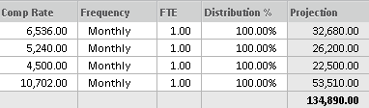

(2) enter the monthly amounts in the timespan
(TIMESPAN will always OVERRIDE the COMP RATE calculation)
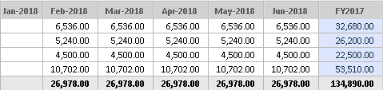

NOTE: Only data from the EXPENDITURE PROJECTION version for OPEN periods will display in reports. ACTUAL data will display in reports for CLOSED periods.

PERSONNEL – STUDENT

The PERSONNEL – STUDENT sheet is where users view, enter, and update information for student accounts.

Click SHEETS from the navigation menu to see your sheets listed in the submenu. Click PERSONNEL – STUDENT to view sheet.
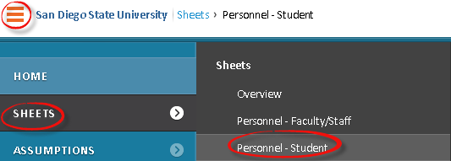

DATA ENTRY – FY INITIAL BUDGET

Click on FY INITIAL BUDGET to display version.

Select the LEVEL to display from the level drop-down menu.

Budget & Finance will pre-populate the PERSONNEL – STUDENT sheet for the FY INITIAL BUDGET version based upon direction from each divisional coordinator.

The columns in the PERSONNEL – STUDENT sheet allow users flexibility to plan their initial budget based on divisional/college/department business process.

- Level – required (will only display if you select a parent level)
- Org-Activity – required (format ORGXX-ACT)
- Org-Activity Description – view only (attribute of ORG-ACTIVITY)
- Natural Account – required
- Account Description – view only (attribute of NATURAL ACCOUNT)
- Endeavor – required
- Fund – required
- Function – required
- Start Date – optional (required for Lump Sum)
- End Date – optional
- Position Number – optional, select from drop-down list
- HeadCount – optional
- JobCode – optional, select from drop-down list
- Title – optional
- Union Code – optional, select from drop-down list
- Empl ID – optional, select from drop-down list (updated monthly after payroll posts)
- Empl Name – view only (attribute of EMPL ID)
- Comp Rate – amount that applies to Frequency (i.e. hourly salary)
- Frequency – select from drop-down list
  - Annual: amount for fiscal year (Frequency = 1)
  - Hourly: amount for single month (Frequency = 12)
  - Lump Sum does not apply to FY INITIAL BUDGET version
- Hours – required for Hourly Frequency
- Projection – view only
  - Annual = Comp Rate
  - Monthly = Comp Rate * Hours
  - Lump Sum does not apply to FY INITIAL BUDGET version
- Bud TRF Base – view only (does not apply to FY INITIAL BUDGET version)
- Bud TRF 1x - view only (does not apply to FY INITIAL BUDGET version)
- Total Projection – view only (same as Projection)
- PY Initial Budget – optional (may be pre-populated)
- Notes – optional
- Emp Group – optional
- Period(s) – displays period(s) based on display options selected

DATA ENTRY – EXPENDITURE PROJECTION

Click on EXPENDITURE PROJECTION to display version.

Select the LEVEL to display from the level drop-down menu.

Budget & Finance will pre-populate the PERSONNEL – STUDENT sheet for the EXPENDITURE PROJECTION version as a copy of the data in the INITIAL BUDGET version.

The columns in the PERSONNEL – STUDENT sheet allow users flexibility to plan their expenditures based on divisional/college/department business process.

- Level – required (will only display if you select a parent level)
- Org-Activity – required (format ORGXX-ACT)
- Org-Activity Description – view only (attribute of ORG-ACTIVITY)
- Natural Account – required
- Account Description – view only (attribute of NATURAL ACCOUNT)
- Endeavor – required
- Fund – required
- Function – required
- Start Date – optional (required for Lump Sum)
- End Date – optional
- Position Number – optional, select from drop-down list
- HeadCount – optional
- JobCode – optional, select from drop-down list
- Title – optional
- Union Code – optional, select from drop-down list
- Empl ID – optional, select from drop-down list (updated monthly after payroll posts)
- Empl Name – view only (attribute of EMPL ID)
- Comp Rate – amount that applies to Frequency (i.e. hourly salary)
- Frequency – select from drop-down list
  - Annual: amount for fiscal year (Frequency = 1)
  - Hourly: amount for single month (Frequency = 12)
  - Lump Sum: lump amount will apply to month entered in Start Date
- Hours – required for Hourly Frequency
- Projection – view only (calculated as Comp Rate * Frequency * hours (if applicable) * remaining months/open periods) (does not apply to Lump Sum)
- Bud TRF Base – view only (does not apply to EXPENDITURE PROJECTION version)
- Bud TRF 1x - view only (does not apply to EXPENDITURE PROJECTION version)
- Total Projection – view only (same as Projection)
- PY Initial Budget – optional (may be pre-populated)
- Notes – optional
- Emp Group – optional
- Period(s) – displays period(s) based on display options selected

Users have the option to (1) use the Comp Rate calculation
(Comp Rate * Frequency * FTE * Distribution %) or
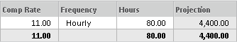

(2) enter the monthly amounts in the timespan
(TIMESPAN will always OVERRIDE the COMP RATE calculation)
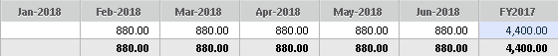

NOTE: Only data from the EXPENDITURE PROJECTION version for OPEN periods will display in reports. ACTUAL data will display in reports for CLOSED periods.

OPERATING EXPENSE

The OPERATING EXPENSE sheet is where users view, enter, and update information for operating accounts.

Click SHEETS from the navigation menu to see your sheets listed in the submenu. Click OPERATING EXPENSE to view sheet.
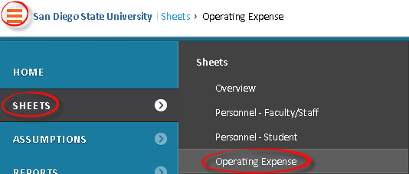

DATA ENTRY – FY INITIAL BUDGET

Click on FY INITIAL BUDGET to display version.

Select the LEVEL to display from the level drop-down menu.

Budget & Finance will pre-populate the OPERATING EXPENSE sheet for the FY INITIAL BUDGET version based upon direction from each divisional coordinator.

The columns in the OPERATING EXPENSE sheet allow users flexibility to plan their expenditures based on divisional/college/department business process.

- Level – required (will only display if you select a parent level)
- Org-Activity – required (format ORGXX-ACT)
- Org-Activity Description – view only (attribute of ORG-ACTIVITY)
- Natural Account – required
- Account Description – view only (attribute of NATURAL ACCOUNT)
- Endeavor – required
- Fund – required
- Function – required
- Description – optional
- Projection – view only (summation of amounts in timespan)
- Bud TRF Base – view only (does not apply to FY INITIAL BUDGET version)
- Bud TRF 1x - view only (does not apply to FY INITIAL BUDGET version)
- Total Projection – view only (same as Projection)
- PY Initial Budget – optional (may be pre-populated)
- Notes – optional
- Period(s) – displays period(s) based on display options selected

For the FY INITIAL BUDGET version you only need to enter amounts into the JULY period.

Click on the SAVE icon from the toolbar to save.

The amounts saved to the JULY period will populate the projection.

DATA ENTRY – EXPENDITURE PROJECTION

Click on EXPENDITURE PROJECTION to display version.

Select the LEVEL (Department/Organization) to display from the level drop-down menu.

Budget & Finance will pre-populate the OPERATING EXPENSE sheet for the EXPENDITURE PROJECTION version as a copy of the data in the INITIAL BUDGET version.

The columns in the OPERATING EXPENSE sheet allow users flexibility to plan their expenditures based on divisional/college/department business process.

- Level – required (will only display if you select a parent level)
- Org-Activity – required (format ORGXX-ACT)
- Org-Activity Description – view only (attribute of ORG-ACTIVITY)
- Natural Account – required
- Account Description – view only (attribute of NATURAL ACCOUNT)
- Endeavor – required
- Fund – required
- Function – required
- Description – optional
- Projection – view only (summation of amounts in timespan)
- Bud TRF Base – view only (does not apply to EXPENDITURE PROJECTION version)
- Bud TRF 1x - view only (does not apply to EXPENDITURE PROJECTION version)
- Total Projection – view only (same as Projection)
- PY Initial Budget – optional (may be pre-populated)
- Notes – optional
- Period(s) – displays period(s) based on display options selected

Users enter/edit the monthly amounts in the timespan for open periods.
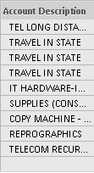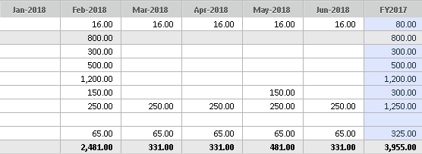

Amounts flow to the Projection and Total Projection columns.
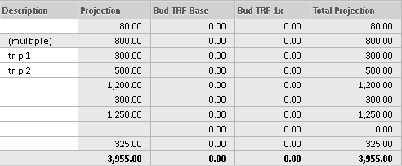

NOTE: Only data from the EXPENDITURE PROJECTION version for OPEN periods will display in reports. ACTUAL data will display in reports for CLOSED periods.

REVENUE

The REVENUE sheet is where users view, enter, and update information for revenue accounts.

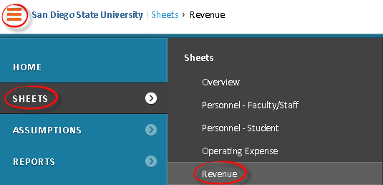

DATA ENTRY – FY INITIAL BUDGET

Click on FY INITIAL BUDGET to display version.

Select the LEVEL to display from the level drop-down menu.

Budget & Finance will pre-populate the REVENUE sheet for the FY INITIAL BUDGET version based upon direction from each divisional coordinator.

The columns in the REVENUE sheet allow users flexibility to plan their expenditures based on divisional/college/department business process.

- Level – required (will only display if you select a parent level)
- Org-Activity – required (format ORGXX-ACT)
- Org-Activity Description – view only (attribute of ORG-ACTIVITY)
- Natural Account – required
- Account Description – view only (attribute of NATURAL ACCOUNT)
- Endeavor – required
- Fund – required
- Function – required
- Description – optional
- Projection – view only (summation of amounts in timespan)
- Bud TRF Base – view only (does not apply to FY INITIAL BUDGET version)
- Bud TRF 1x - view only (does not apply to FY INITIAL BUDGET version)
- Total Projection – view only (same as Projection)
- PY Initial Budget – optional (may be pre-populated)
- Notes – optional
- Period(s) – displays period(s) based on display options selected

For the FY INITIAL BUDGET version you only need to enter amounts into the JULY period.

Click on the SAVE icon from the toolbar to save.

The amounts saved to the JULY period will populate the projection.

DATA ENTRY – EXPENDITURE PROJECTION

Click on EXPENDITURE PROJECTION to display version.

Select the LEVEL (Department/Organization) to display from the level drop-down menu.

Budget & Finance will pre-populate the REVENUE sheet for the EXPENDITURE PROJECTION version as a copy of the data in the INITIAL BUDGET version.

The columns in the REVENUE sheet allow users flexibility to plan their expenditures based on divisional/college/department business process.

- Level – required (will only display if you select a parent level)
- Org-Activity – required (format ORGXX-ACT)
- Natural Account – required
- Account Description – view only (attribute of NATURAL ACCOUNT)
- Endeavor – required
- Fund – required
- Function – required
- Source – optional, select from drop-down list
- Description – optional
- Projection – view only (summation of amounts in timespan)
- Bud TRF Base – view only (does not apply to EXPENDITURE PROJECTION version)
- Bud TRF 1x - view only (does not apply to EXPENDITURE PROJECTION version)
- Total Projection – view only (same as Projection)
- PY Initial Budget – optional (may be pre-populated)
- Notes – optional
- Period(s) – displays period(s) based on display options selected

Users enter the monthly amounts in the timespan
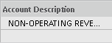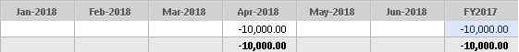

Amounts flow to the Projection and Total Projection columns.
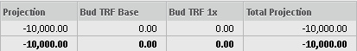

NOTE: Only data from the EXPENDITURE PROJECTION version for OPEN periods will display in reports. ACTUAL data will display in reports for CLOSED periods.

BUDGET – TRANSFERS

The BUDGET – TRANSFERS sheet is used ONLY in the WORKING BUDGET version.

Click SHEETS from the navigation menu to see your sheets listed in the submenu. Click BUDGET - TRANSFERS to view sheet.
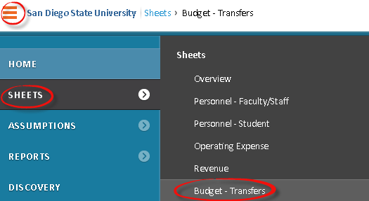

The existing budget transfer process whereby a department submits a budget transfer form to Budget & Finance for processing in Oracle is unchanged with the exception of a couple new required fields (1) Budget Category and (2) Position.

These two new fields assist the flow of the budget transfer data within Adaptive. The budget transfer data is imported into the BUDGET – TRANSFERS sheet.

The data from the BUDGET – TRANSFERS sheet then flows to the (1) PERSONNEL – FACULTY STAFF sheet, (2) PERSONNEL – STUDENT sheet, (3) OPERATING EXPENSE sheet, and (4) REVENUE sheet based on the combination of GL account segments, position number (if applicable) and budget category. An example of the PERSONNEL – FACULTY STAFF sheet showing

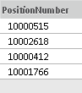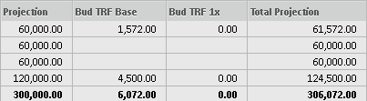

ASSUMPTIONS – POSITION

The ASSUMPTIONS - POSITION sheet is where users may view, enter, and update the benefit rate assumption for self-supporting positions. Users have the option to assign a specific benefit rate by position in the ASSUMPTIONS – POSITION sheet otherwise the default benefit rate as published by Budget & Finance will apply to benefit calculations within the PERSONNEL sheets.

Click SHEETS from the navigation menu to see your sheets listed in the submenu. Click ASSUMPTIONS - POSITION to view sheet. 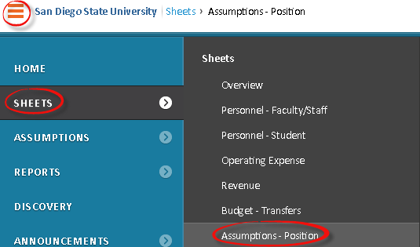

DATA ENTRY – FY INITIAL BUDGET

Click on the LEVELS drop-down menu and select a LEVEL.

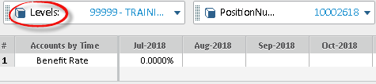

Click on the POSITION NUMBER drop-down menu and select a POSITION.
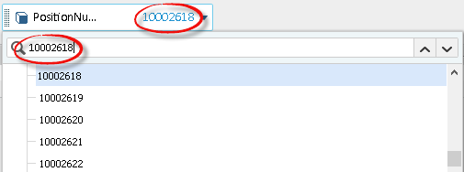

Enter a BENEFIT RATE in the JULY period. Only the JULY period applies to the initial budget process as the JULY period is used for all calculations.

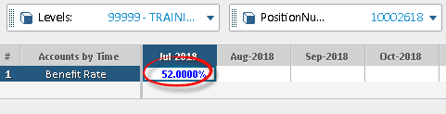

Click on the SAVE icon from the toolbar to save.
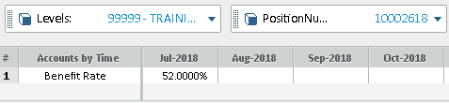

Review how the data in the ASSUMPTIONS – POSITION sheet is used in the benefits calculation in the PERSONNEL – FACULTY/STAFF sheet:

Click SHEETS from the navigation menu to see your sheets listed in the submenu. Click PERSONNEL – FACULTY/STAFF to view sheet.

Right click on a POSITIONNUMBER and click on ROW DETAILS.
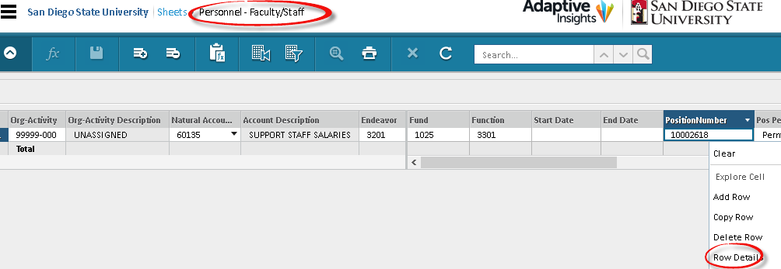

A new window (pop-up) will open and display the benefits amount and rate for the position selected. Use the SCROLL BAR to display data to the left and right.
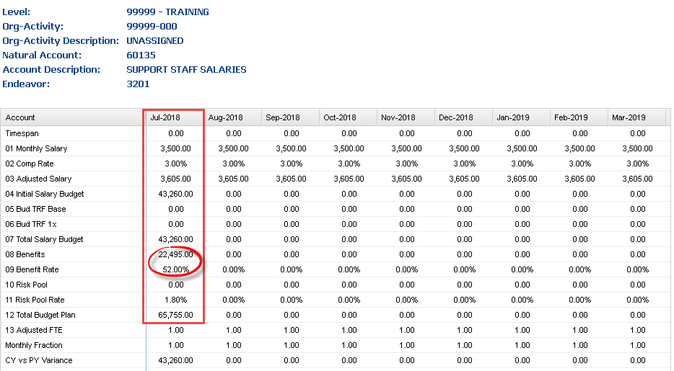

DATA ENTRY – EXPENDITURE PROJECTION

Click on the LEVELS drop-down menu and select a LEVEL.
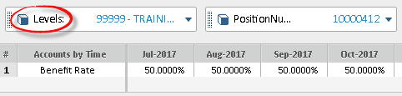

Click on the POSITION NUMBER drop-down menu and select a POSITION.
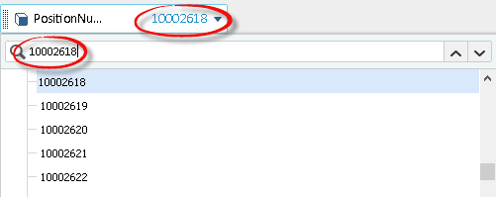

Enter a BENEFIT RATE in the desired period.
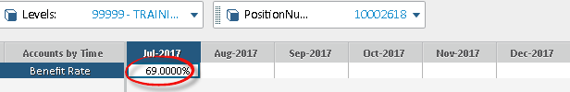

Right click and select COPY TO END to apply rate to future periods.
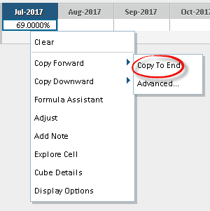

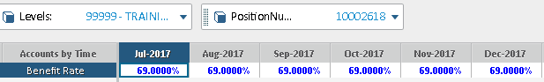

Click on the SAVE icon from the toolbar to save.
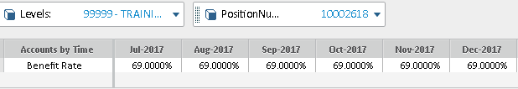

Follow the same steps to edit future periods.
Click on the SAVE icon from the toolbar to save.

Review how the data in the ASSUMPTIONS – POSITION sheet is used in the benefits calculation in the PERSONNEL – FACULTY/STAFF sheet:

Click SHEETS from the navigation menu to see your sheets listed in the submenu. Click PERSONNEL – FACULTY/STAFF to view sheet.

Right click on a POSITIONNUMBER and click on ROW DETAILS.

A new window (pop-up) will open and display the benefits amount and rate for the position selected. Use the SCROLL BAR to display data to the left and right.

REPORTS

NAVIGATION

Click REPORTS from the navigation menu to see your favorite reports listed in the submenu. Click any report to view it.
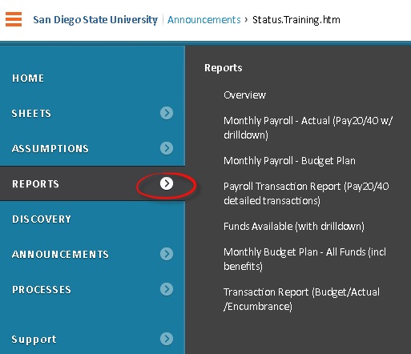

Or, click OVERVIEW to go to the reports overview page.
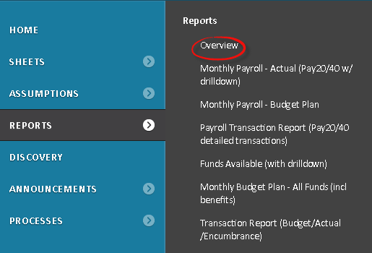

REPORTS OVERVIEW PAGE

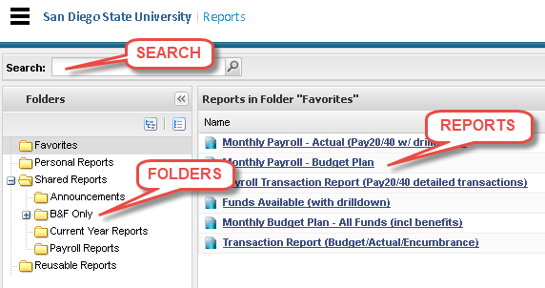

SEARCH

Enter KEYWORDS (search criteria) in the search and press ENTER. A Search Results folder appears as the last folder in the left folder pane and all reports with titles that match your search keywords are listed in the right pane. These remain in the Search Results folder until you conduct another search.

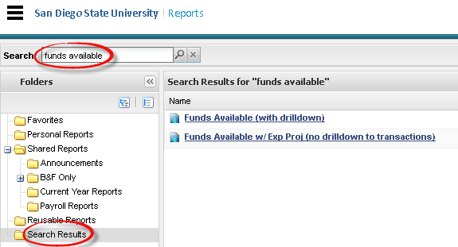

FOLDERS PANE

Expand and collapse folders to find reports. Click on a FOLDER and the reports saved there are listed in the reports list.

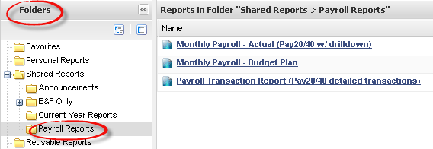

The default folders can't be deleted or renamed, but you can create subfolders within Personal reports. Default folders include:
- Favorites: To add reports to your favorites, right-click on any report and click ADD TO FAVORITES.
- Personal Reports: Any report you create saves to Personal Folders by default. You can copy any report to this folder by SAVING AS when the report is open or by selecting COPY TO PERSONAL FOLDER from the context menu (right-click on report).
- Shared Reports: Contains reports created by others that were shared with you.
- Reusable Reports: Contains reports that you or others have saved as reusable.

Use the EXPAND or COLLAPSE icon next to Personal or Shared folders to navigate any subfolders and browse for reports.

To create a new folder: right-click on PERSONAL REPORTS and click ADD NEW FOLDER. Enter a NAME for the new subfolder and press ENTER.

REPORTS LIST

View a list of reports within a selected folder. Click the REPORT to run it. Depending on the report, you may be asked to select report parameters.

Or RIGHT-CLICK to select actions from the context menu.
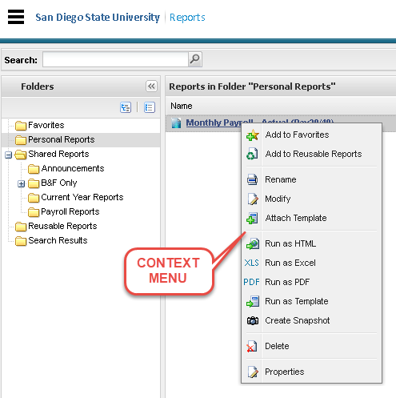

- Add to Favorites
The favorites folder is displayed first when you initially visit the reports tab during a session. You can add the reports you run most frequently to your Favorites to make them easily accessible.
- Add to Reusable Reports
Selecting this option creates a copy of the report in the Reusable Reports Folder. Once a report is copied to another location using this option, the new report and the base report are completely independent.
- Copy to Personal Folder
Selecting this option creates a copy of the report in the Personal Folder. Once a report is copied to another location using this option, the new report and the base report are completely independent.
- Email Report
Selecting this option brings up the Email Report dialog where you can specify users, groups, and/or levels to which you want to email the report.
- Rename
Users can rename any of the reports they own using this option.
- Modify
When you select this option, you are taken to the report builder and you have the option to modify any element that was established when the report was created. All users can modify a report that they own. Save as to your Personal Report folder to modify a report that you do not own.
- Attach Template
Templates can be attached to any report to customize formatting on the report. Many clients use templates to create ready-to-go reports with the company logo and custom formatting.
- Run as HTML
This option makes it easy for a user to run a report with a preferred output format other than HTML as HTML.
- Run as ExcelTM
This option makes it easy for a user to run a report with a preferred output format other than ExcelTM as ExcelTM.
- Run as PDF
This option makes it easy for a user to run a report with a preferred output format other than PDF as PDF.
- Run as Template
This option makes it easy for a user to run a report with a preferred output format other than ExcelTM Template with a template. This option only appears if a template has been attached to the report.
- Create Snapshot
Selecting this option allows you to create a snap-shot of a report or a copy of the report at a certain point in time.
- Delete
Users can delete any of the reports they own using this option.
- Properties
Selecting this option brings up the Report Properties dialog. In this dialog, you can change the report name and description, you can find the URL to the report, the location in which the report is saved, the report creator and the date and time the report was last viewed.

RUN A REPORT

Click on a REPORT from the reports list to run the report.

You may be asked to select report parameters. Select PARAMETERS and click RUN REPORT. Report parameters will vary by report.
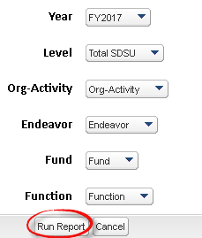

REPORT DRILLDOWN TO TRANSACTION

Click on an AMOUNT in the report display.
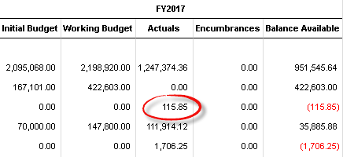

A new window (pop-up) will open. Click on DRILL INTO TRANSACTIONS in the top right of the window. A transaction report will display including the transaction detail that makes up the total selected on the report.

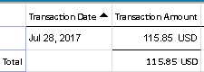

PRINT A REPORT

PRINTABLE VIEW

Click on the PRINTABLE VIEW icon.


Select OPEN WITH or SAVE FILE and click OK.
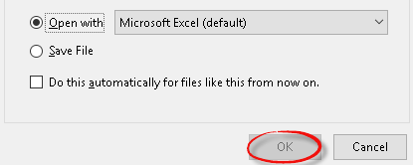

EXPORT REPORT

Click on the EXPORT REPORT icon.


Select either EXPORT TO EXCEL or EXPORT TO PDF.
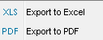

ADAPTIVE REPORT TRANSLATION

Oracle Report: | Adaptive Report:
Current Year | Funds Available (with drilldown)
Account Analysis | Transaction Report (Budget/Actual/Encumbrance)
SDSU Actuals Inquiry Report | Transaction Report (Budget/Actual/Encumbrance)
SDSU All Encumbrance with GL Balance Detail | Transaction Report (Budget/Actual/Encumbrance)
Pay20/40 | Monthly Payroll – Actual (Pay20/40 w/ drilldown)
Pay20/40 | Payroll Transaction Report (Pay20/40 detailed transactions)
Pay30 | Monthly Payroll – Budget Plan (Pay30 w/ drilldown)

MATRIX REPORTS

The most commonly-used type of report as they have the most functionality. You can place various elements like accounts, levels, and so on in rows and columns. Matrix reports also let you use parameters, a way to change what the report displays from drop-down menus on the report itself.

Click on a matrix REPORT from the reports list to run the report.

Monthly Payroll – Actual (Pay20/40 w/ drilldown)

The Monthly Payroll – Actual (Pay20/40 w/ drilldown) report is a summarized version of the Pay20/40 reports and allows drilldown to transaction detail. It can be run to exclude benefits (Pay20) or include benefits (Pay40). It includes Labor Distribution Adjustments as well as Accounting Journals for payroll NACCTs.

This report includes the following columns: (1) Level, (2) Org-Activity, (3) Accounts, (4) Endeavor, (5) Fund, (6) Function, (7) Position Number, (8) Employee Name and (9) Employee ID.

This report provides ACTUAL PAYROLL EXPENSE data by month and in total for the fiscal year. Only months where payroll has posted will display data.

When this report is run, users can define the parameters to limit the display of data in the report. Currently, ACCOUNT is not a parameter (Adaptive support ticket in process to resolve).

Select PARAMETERS and click RUN REPORT.
Note: ACCOUNT 60100 Salary will include only salary accounts.
ACCOUNT 60099 Salary & Benefits will include salary and benefit accounts.

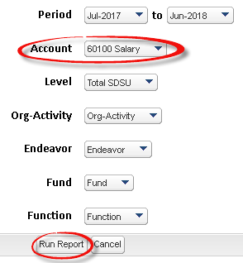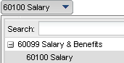

Monthly Payroll – Budget Plan (Pay30 w/ drilldown)

The Monthly Payroll – Budget Plan (Pay30 w/ drilldown) report is a summarized version of the Pay30 report and allows drilldown to transaction detail. It can be run to exclude benefits or include benefits. This report also includes expenditure projections (previously managed in “shadow” systems) if the department is inputting projections into the Expenditure Projection version providing a more complete view of funds available. It includes Labor Distribution Adjustments as well as Accounting Journals for payroll NACCTs.

This report includes the following columns: (1) Level, (2) Org-Activity, (3) Accounts, (4) Endeavor, (5) Fund, (6) Function, (7) Position Number, (8) Employee Name and (9) Employee ID.

This report provides ACTUAL PAYROLL EXPENSE data and PROJECTED PAYROLL EXPENSE data by month and in total for the fiscal year. It also includes the (1) Initial Budget and (2) Working Budget and provides a budget balance for the fiscal year.

When this report is run, users can define the parameters to limit the display of data in the report. Currently, ACCOUNT is not a parameter (Adaptive support ticket in process to resolve).

Select PARAMETERS and click RUN REPORT.
Note: ACCOUNT 60100 Salary will include only salary accounts.
ACCOUNT 60099 Salary & Benefits will include salary and benefit accounts.

Report will display ACTUAL expenditures for closed periods and PROJECTED expenditures for open periods.

Funds Available (with drilldown)

The Funds Available (with drilldown) report is a summarized funds available report, similar to the Oracle funds inquiry, and allows drilldown to transaction detail.

This report includes the following columns: (1) Level, (2) Org-Activity, (3) Accounts, (4) Endeavor, (5) Fund, and (6) Function.

This report provides the (1) Initial Budget, (2) Working Budget, (3) Actuals, (4) Encumbrance, and (5) Balance Available.

When this report is run, users can define the parameters to limit the display of data in the report. Currently, ACCOUNT is not a parameter (Adaptive support ticket in process to resolve).

Select PARAMETERS and click RUN REPORT.
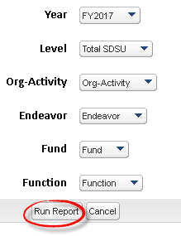

Funds Available w/ Exp Proj (no drilldown)

The Funds Available w/ Exp Proj (no drilldown) report is a summarized funds available report, similar to the Oracle funds inquiry, and allows drilldown to transaction detail. This report also includes expenditure projections (previously managed in “shadow” systems) if the department is inputting projections into the Expenditure Projection version providing a more complete view of funds available.

This report includes the following columns: (1) Level, (2) Org-Activity, (3) Accounts, (4) Endeavor, (5) Fund, and (6) Function.

This report provides the (1) Initial Budget, (2) Working Budget, (3) Actuals, (4) Encumbrance, (5) YTD Balance Available, and (6) YTD % Expended and also adds (7) Expenditure Projection, (8) Projected Balance Available, and (9) Projected % Expended.

When this report is run, users can define the parameters to limit the display of data in the report. Currently, ACCOUNT is not a parameter (Adaptive support ticket in process to resolve).

Select PARAMETERS and click RUN REPORT.
Users should select the most recent CLOSED period as the TIME parameter to ensure that the report displays ACTUAL expenditures for closed periods and PROJECTED expenditures for open periods.
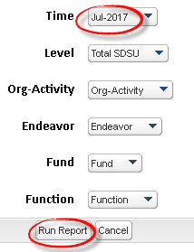

Monthly Budget Plan – All Funds (incl benefits)

The Monthly Budget Plan- All Funds (incl benefits) report is a summarized funds available report, similar to the Oracle funds inquiry, and allows drilldown to transaction detail. This report also includes expenditure projections (previously managed in “shadow” systems) if the department is inputting projections into the Expenditure Projection version providing a more complete view of funds available. This report includes benefits.

This report includes the following columns: (1) Level, (2) Org-Activity, (3) Accounts, (4) Endeavor, (5) Fund, and (6) Function.

This report provides the (1) Initial Budget, (2) Working Budget, (3) YTD Encumbrance, (4) YTD Actual/Expense Projection, (5) Balance Available, and (6) Actual/Expense Projections by month and in total for the fiscal year.

When this report is run, users can define the parameters to limit the display of data in the report.

When this report is run, users can define the parameters to limit the display of data in the report. Currently, ACCOUNT is not a parameter (Adaptive support ticket in process to resolve).

Select PARAMETERS and click RUN REPORT.
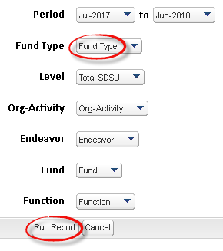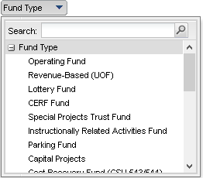

Report will display ACTUAL expenditures for closed periods and PROJECTED expenditures for open periods.

Monthly Budget Plan – UOF/RB Only (excl benefits)

The Monthly Budget Plan- UOF/RB Only (excl benefits) report is a summarized funds available report, similar to the Oracle funds inquiry, and allows drilldown to transaction detail. This report also includes expenditure projections (previously managed in “shadow” systems) if the department is inputting projections into the Expenditure Projection version providing a more complete view of funds available. This report includes on University Operating and Revenue-Based funds and excludes benefits.

This report includes the following columns: (1) Level, (2) Org-Activity, (3) Accounts, (4) Endeavor, (5) Fund, and (6) Function.

This report provides the (1) Initial Budget, (2) Working Budget, (3) YTD Encumb, (4) YTD Actual/Expense Projection, (5) Balance Available, and (6) Actual/Expense Projections by month and in total for the fiscal year.

When this report is run, users can define the parameters to limit the display of data in the report.

When this report is run, users can define the parameters to limit the display of data in the report. Currently, ACCOUNT is not a parameter (Adaptive support ticket in process to resolve).

Select PARAMETERS and click RUN REPORT.
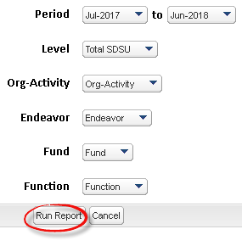
Report will display ACTUAL expenditures for closed periods and PROJECTED expenditures for open periods.

MODEL REPORTS

Row or list-based reports, like personnel. Only displays data from modeled sheets.

Modeled reports are used during the initial budget development process.

TRANSACTION REPORTS

Row or list-based reports. Only display data from the transaction module.

Payroll Transaction Report (Pay20/40 detailed transactions)

This Payroll Transaction Report (Pay20/40 detailed transactions) is a detailed version of the Pay20/Pay40 reports. It can be run to exclude benefits or include benefits. It includes Labor Distribution Adjustments as well as Accounting Journals for payroll NACCTs.

This report includes the following columns: (1) Transaction Type, (2) Organization, (3) Org-Activity, (4) Accounts, (5) Endeavor, (6) Fund, (7) Function, (8) Pool ID, (9) Source/Type/Ledger, (10) Description, (11) Transaction Amount, (12) Transaction Date, (13) Pay Period, (14) Pay Check #, (15) Name, (16) REDID, (17) Employee ID, (18) Employee Record No., (19) FTE, (20) Rate, (21) Position Number, (22) Job Code and (23) Union Code.

This report provides detailed ACTUAL PAYROLL EXPENSE data.

RIGHT-CLICK on the report and select MODIFY from the context menu.
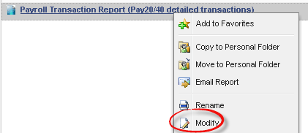

Click on the FILTERS icon.


Change the TRANSACTION DATES to reflect the month(s) of data you wish to display in your report filters.

Note: If you would NOT like benefits to display in your report, you may change the ACCOUNT less than filter from 604 to 603 and the report will exclude benefits.

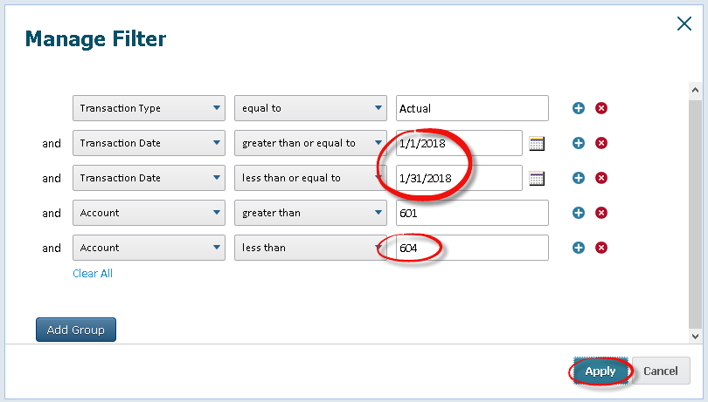

Click on APPLY
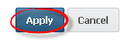

Click on the RUN icon.


Transaction Report – Budget/Actual/Encumbrance

This Transaction Report is a detailed transaction report, similar to the Oracle SDSU Actuals Inquiry report. However, it can be run to include (1) Budget transactions, (2) Actual transactions, (3) Encumbrance transactions, or (4) all transactions.

This report includes the following columns: (1) Transaction Type, (2) Transaction Date, (3) Transaction Amount (4) Organization, (5) Org-Activity, (6) Accounts, (7) Endeavor, (8) Fund, (9) Function, (10) Description, (11) Reference, (12) Transaction ID, (13) Source/Type/Ledger, (14) Vendor, (15) Transaction Type, (16) Name, (17) REDID, (18) Employee ID, (19) Employee Record No., (20) FTE, (21) Rate, (22) Position Number, (23) Job Code, (24) Union Code, (25) Pool ID, (26) Pay Period, and (27) Pay Check #.

This report provides detailed transaction data.

RIGHT-CLICK on a report and select MODIFY from the context menu.
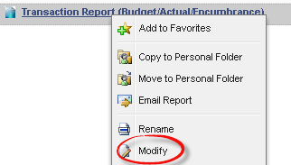

Click on the FILTERS icon.


Modify the TRANSACTION TYPE filter to either BUDGET, ACTUAL or ENCUMBRANCE.
Or delete filter for transaction type if you want ALL transaction types.
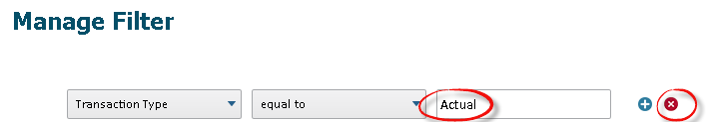

Modify the TRANSACTION DATES filter to reflect the month(s) of data you wish to display in your report.
Click APPLY.
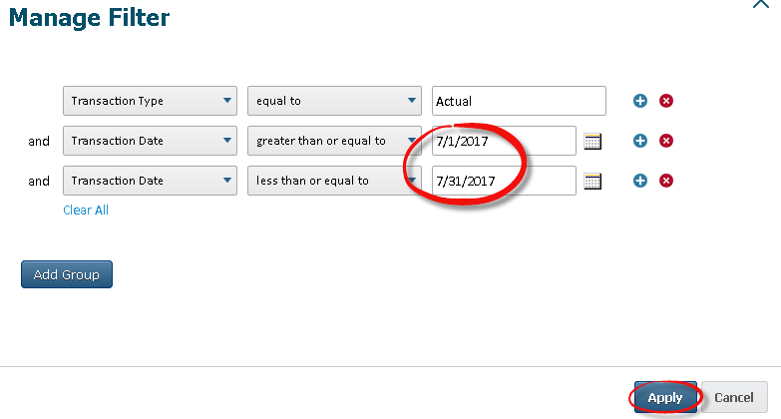

Click on RUN REPORT to see changes in report display.


Click on SAVE REPORT to save these changes to the report.
Note: You can only save modifications to reports in your Personal Reports folder. You can select SAVE AS to save the report in your Personal Reports folder.


REPORT FILTERS

MATRIX REPORT PARAMETERS

User can define the parameters to limit the display of data in the report. Parameter options will vary by report and are only available for matrix reports.
Currently, ACCOUNT is not a parameter (Adaptive support ticket in process to resolve).
Select PARAMETERS and click RUN REPORT.
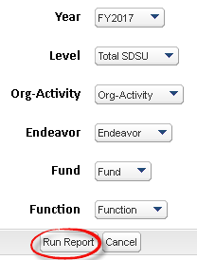

TRANSACTION REPORT FILTERS

RIGHT-CLICK on a report and select MODIFY from the context menu.

Click on the FILTERS icon.

Modify the TRANSACTION TYPE filter to either BUDGET, ACTUAL or ENCUMBRANCE.
Or delete filter for transaction type if you want ALL transaction types.

Modify the TRANSACTION DATES filter to reflect the month(s) of data you wish to display in your report.
Click APPLY.

Click on RUN REPORT to see changes in report display.

Click on SAVE REPORT to save these changes to the report.
Note: You can only save modifications to reports in your Personal Reports folder. You can select SAVE AS to save the report in your Personal Reports folder.

REPORT DESIGN ELEMENTS

MATRIX REPORT

Users can modify the design elements for reports in their Personal Reports folder. RIGHT-CLICK on a report and select MODIFY from the context menu.
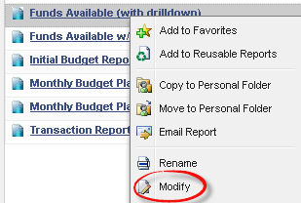

Click on the DIMENSION ATTRIBUTES element.
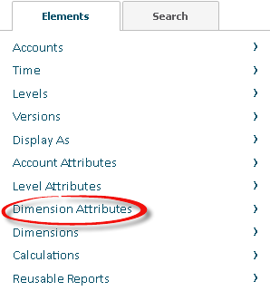

Click on the ORG-ACTIVITY DESCRIPTION element (or select another attribute value) and drag and drop into your report.
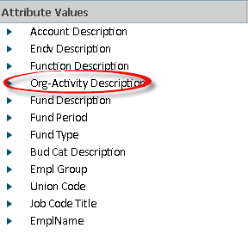

RIGHT-CLICK on Org-Activity Description (or attribute value) and click on MANAGE HIERARCHY.
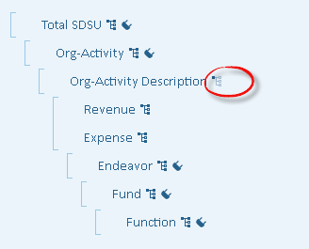

Select EXPAND ALL and click on APPLY.
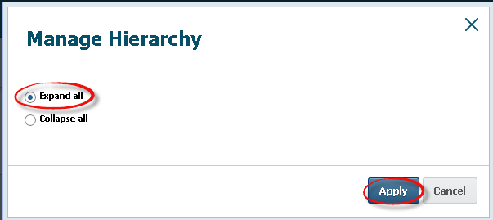

Click on RUN REPORT to see changes in report display.


Click on SAVE REPORT to save these changes to the report.
Note: You can only save modifications to reports in your Personal Reports folder. You can select SAVE AS to save the report in your Personal Reports folder.


TRANSACTION REPORT

Transaction Reports are Row or list-based reports so design options are limited.
RIGHT-CLICK on a report and select MODIFY from the context menu.

RIGHT-CLICK on a column and select an OPTION from the menu.
RENAME – modify the column label
FORMAT – modify the display (i.e. font size and style)
DATE DISPLAY FORMAT – modify the date display
MOVE LEFT – move the column to the left
MOVE RIGHT – move the column to the right
DELETE – delete the column from the report display
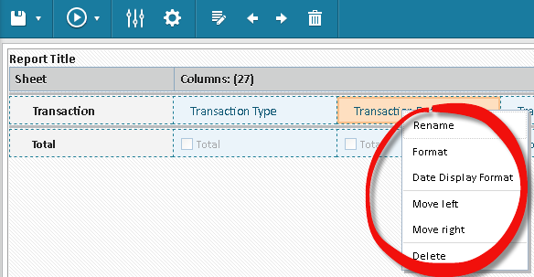

Click on RUN REPORT to see changes in report display.


Click on SAVE REPORT to save these changes to the report.
Note: You can only save modifications to reports in your Personal Reports folder. You can select SAVE AS to save the report in your Personal Reports folder.


MODIFY REPORT PROPERTIES

Users can modify the report properties for reports in their Personal Reports folder. RIGHT-CLICK on a report and select MODIFY from the context menu.
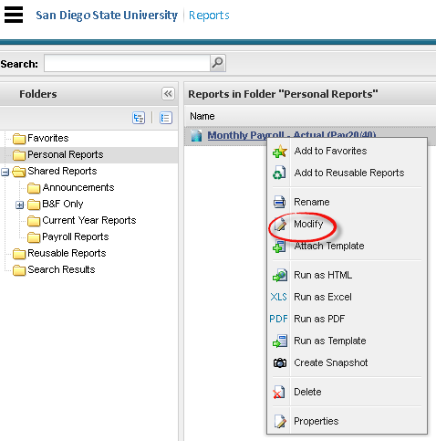

Or if you are viewing a report you can click on the MODIFY REPORT icon.


You are now in report design mode. Click on REPORT PROPERTIES icon.
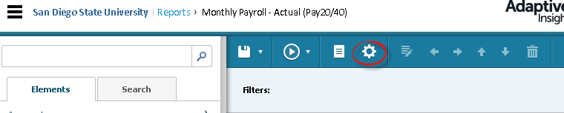

Update report properties as desired and click on APPLY.

Default display settings for a MATRIX report are provided below:
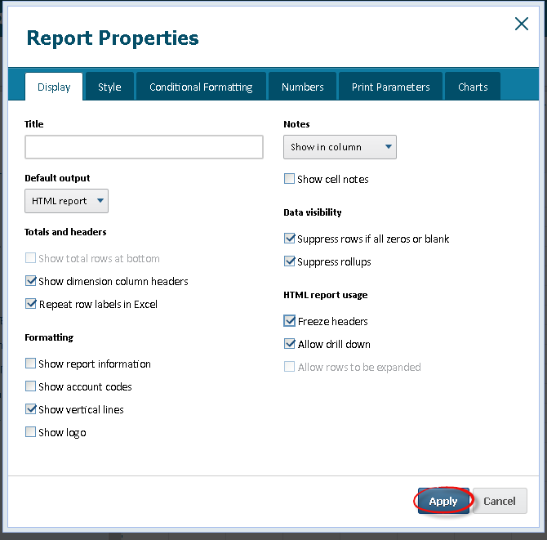

Default display settings for a MODULED or TRANSACTION report are provided below:
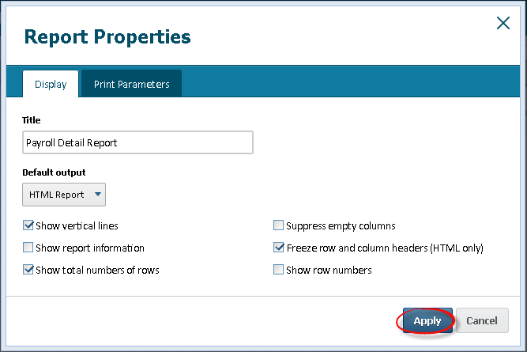

Click on RUN REPORT to see changes in report display.

Click on SAVE REPORT to save these changes to the report.
Note: You can only save modifications to reports in your Personal Reports folder. You can select SAVE AS to save the report in your Personal Reports folder.

CREATE A REPORT BOOK

With report books, users can generate a group of reports with a single request and store them together. A personal report book can include both personal and shared reports. A shared report book can contain only shared reports.

Users can create a report book by clicking on NEW REPORT and then selecting REPORT BOOK from the drop-down menu.

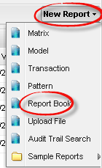

Enter a REPORT BOOK NAME and DESCRIPTION (optional)

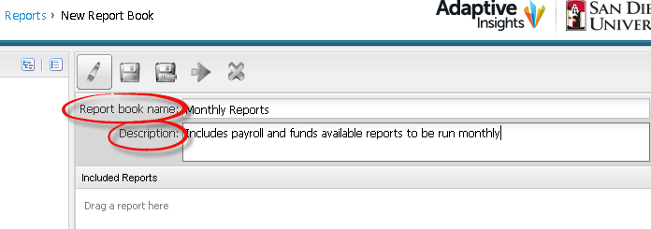

Drag and drop the desired reports from your personal reports or shared reports folders on the left to the INCLUDED REPORTS section.

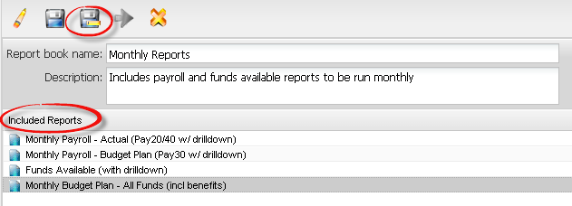

Click on SAVE AS.
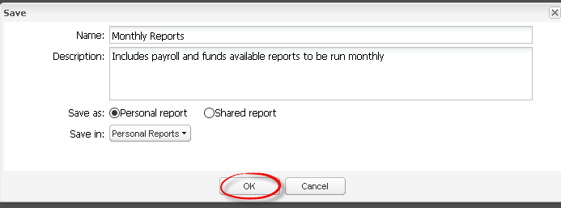

Report books appear in the Report Details Panel along with other report. To run a Report Book, click on the REPORT.
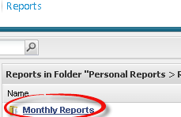

If any of the reports in the Report Book are parameterized, you will need to select the PARAMETERS when prompted and then NEXT. 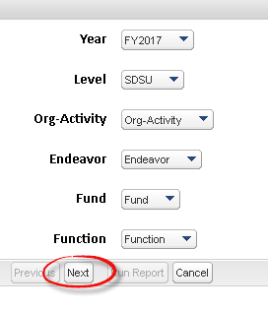
Once all report parameters are selected, click on RUN REPORT. The reports will be saved to a zip drive on your desktop.
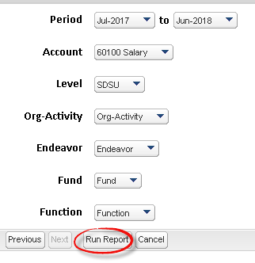
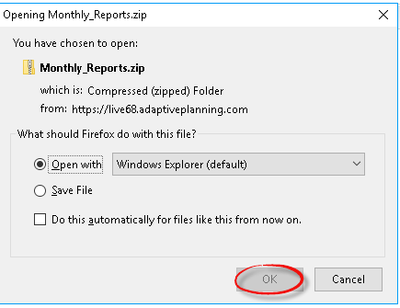

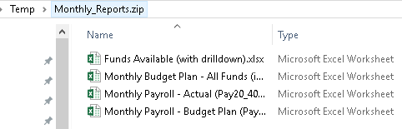

SUPPORT (HELP)

Click SUPPORT from the navigation menu and then click on HELP.
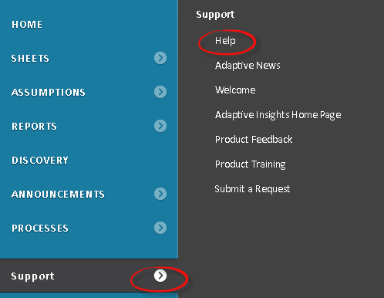
Or click on the QUESTIONMARK icon from the top right navigation.


SEARCH OPTIONS

Users can type in a QUESTION or KEYWORD in the search box and hit ENTER.



Click on a LINK in the search results for FAQ or HOW-TO documentation.

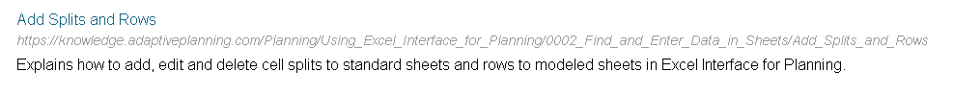

PRODUCT DOCUMENTATION

Users can select PLANNING or REPORTING from the product menu to view FAQ and HOW-TO documentation for these modules.
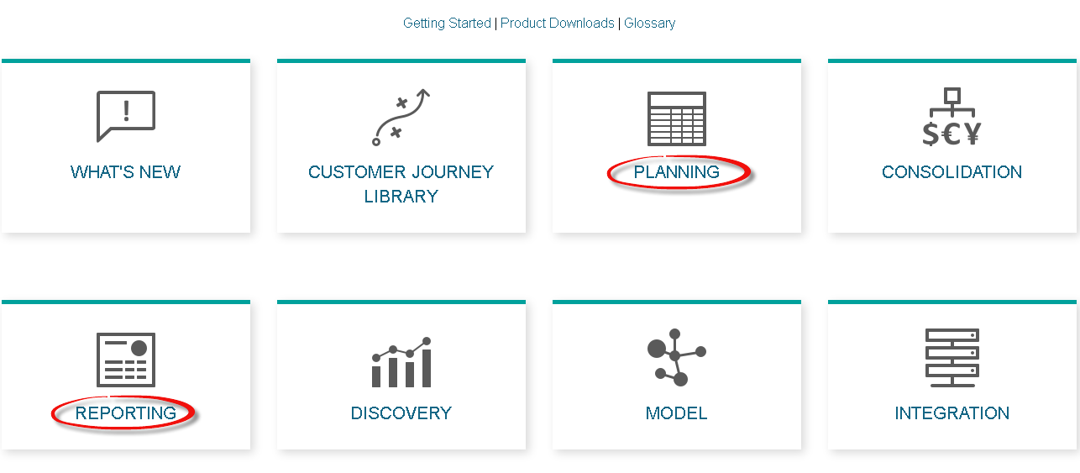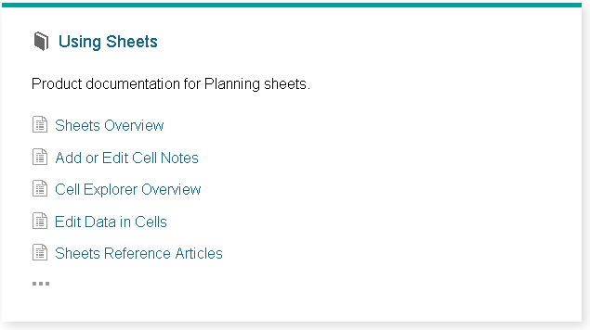
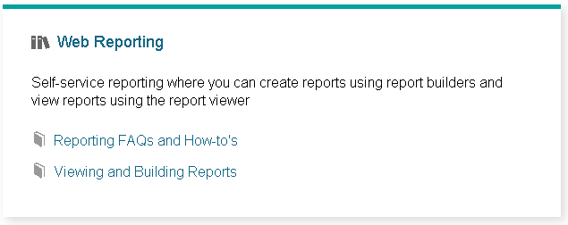

APPENDIX

BASIC TERMINOLOGY

The following terms relate to the structural elements in Adaptive Planning

KEYBOARD SHORTCUTS

Users can access a list of shortcuts by clicking the keyboard icon at the lower right of the page.

Selections are grouped into the following options:

- Working with data
- Sheet navigation
- Extending selections in sheets

WORKING WITH DATA

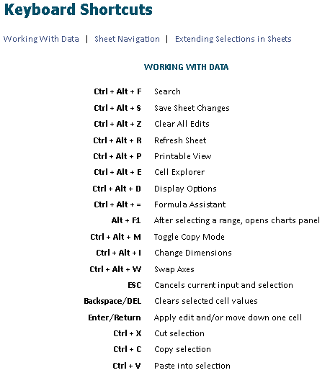

SHEET NAVIGATION

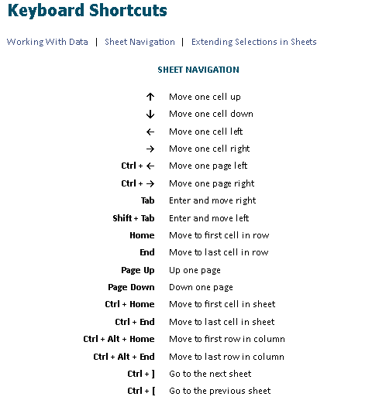

EXTENDING SELECTIONS IN SHEETS

