POSITION MANAGEMENT
PROCESS GUIDE
Position management is the process of planning, managing, and reporting about the positions within an organization, regardless of whether the positions are filled or vacant.

A position gets created or modified in PeopleSoft through a request form, commonly known as Position Action Request (PAR):
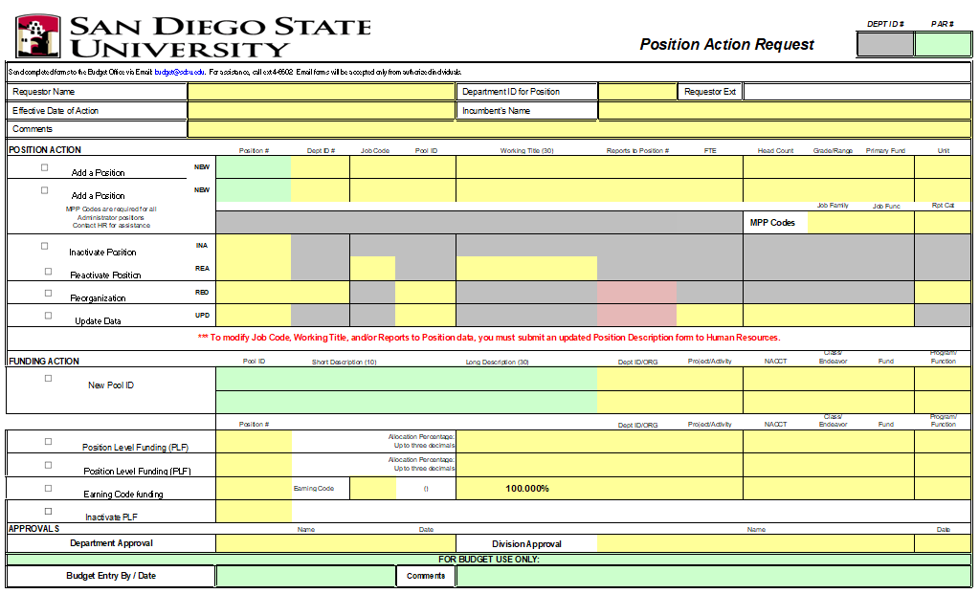

Requirements to create a position:
- Review a current position incumbent report to ensure there are no vacant positions that can be used. Once a position is created it cannot be deleted, but it can be modified.
- Ensure there is budget available to sustain the salary and benefits for the position.
- The PAR for a new position must be approved and submitted by the divisional coordinator via email to budget@sdsu.edu.
Requirements to modify a position:
- Ensure the modification aligns with the history of the position, i.e. don’t modify a student assistant position to staff.
- If changing the funding source, ensure there is budget to sustain the salary and benefits for the position.
- The PAR for a position update must be approved and submitted by the divisional coordinator via email to budget@sdsu.edu.

Below are specific actions to create or modify a position. It is important to select the correct action to track changes in PeopleSoft:
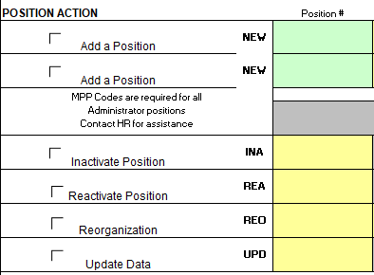

Here is the list of actions and when to use them:
NEW – use this action when creating a new position
INA – use this action when inactivating a position
REA – use this action when reactivating a position.
REO – use this action when moving a position to another department/ORG and/or unit. Please note that retroactive unit changes trigger automatic payroll adjustments and labor distribution adjustments (LDAs) should not be submitted to avoid duplicating adjustments.
UPD – use this action to update the funding (pool ID/position level funding), “working title” and “reports to” updates for multiple headcount positions, FTE and headcount.
The yellow fields are for the requestor to fill out. Please only enter new updates and leave anything else blank.
Here is more information on the different actions:

- NEW
Use the NEW action when requesting a new position. This is the action that requires most of the fields to be filled in by the requestor. B&F will enter this information to produce a position number to be entered in the green field.

Administrator positions require MPP codes to be provided by HR prior to submitting a PAR:
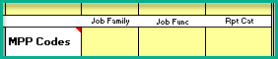

- INA
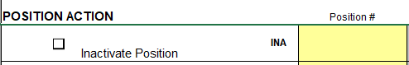
Use the INA action to inactivate a vacant position.

- REA
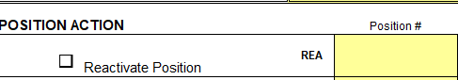
Use the REA action to activate a position.

- REO
Use the REO action when moving a position to another department/organization and/or unit. Do not submit Labor Distribution Adjustments (LDAs) for unit changes, since payroll adjustments happen automatically.

- UPD
Use the UPD action to update any of the yellow fields above. Note that ‘reports to’ updates to single headcount positions need to happen with an updated Position Description (PD) to HR.
FUNDING ACTION
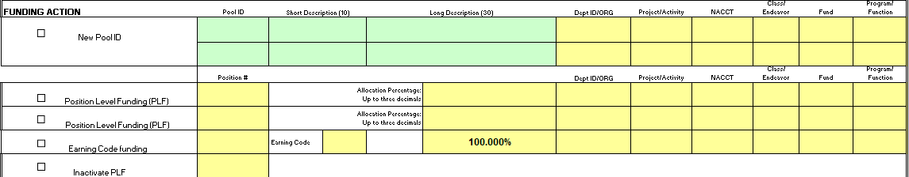

There are three ways to assign funding to a position:
- Pool ID - this is to identify an account string. A pool ID is used to charge 100% of salary and benefits to a single account.
- Position Level Funding (PLF) – this option is used to split the funding into two or more account strings. It is also used to charge 100% of the salary and benefits to a different department/organization.
- Earnings Code – this is to assign an account by earnings code, i.e. overtime = OTP

Pool IDs
A Pool ID is an alphanumeric value created to represent an Oracle account string to charge salary and benefits for a position. The department provides the account string on the PAR and Budget & Finance determines the alphanumeric value.
Example: Dept 70030 needs a pool ID for account 70030.000.60XXX.0000.1006.3301
Budget & Finance will create pool ID G01 with this long description:
70030-000-NATL-0000-1006-3301
Position Level Funding
This funding option is used to split salary and benefits into two or more account strings. It is also used to charge salary and benefits to a different department or organization or to a restricted account, i.e. 1X PBAC allocation.
This is how split funding looks in PeopleSoft:
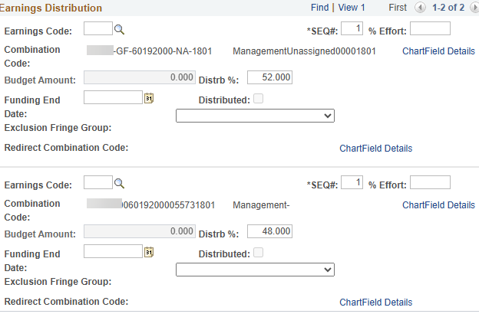

Earnings Code
This funding option is used to charge a specific earnings code to an account different from the regular salary and benefits account.
Here are some commonly used earnings codes used in position level funding:
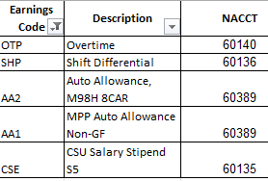
A full list is included in the latest PAR form.
Once a PAR form is completed, it needs to be forwarded to the divisional coordinator for approval, who in turn will forward it to budget@sdsu.edu for processing in PeopleSoft. We will send the processed PAR to the divisional coordinator and anyone who was copied on the request.

